LAB TITLE: APP DEV – DEPLOYING THE APPLICATION INTO KUBERNETES ENGINE: PYTHON

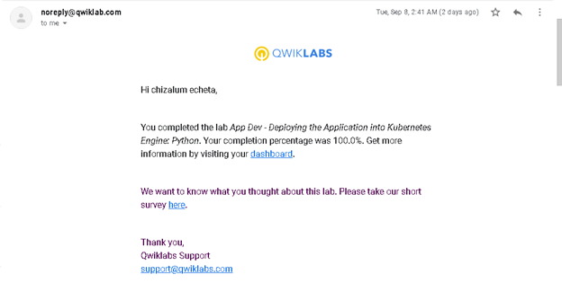

LAB TITLE: APP DEV – DEVELOPING A BACKEND SERVICE: PYTHON

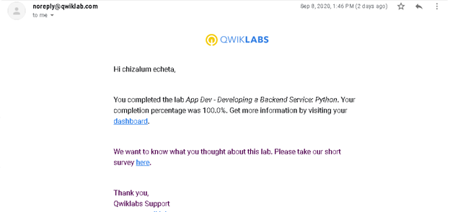

LAB TITLE: APP DEV – DEPLOYING THE APPLICATION INTO APP ENGINE FLEXIBLE ENVIRONMENT: PYTHON

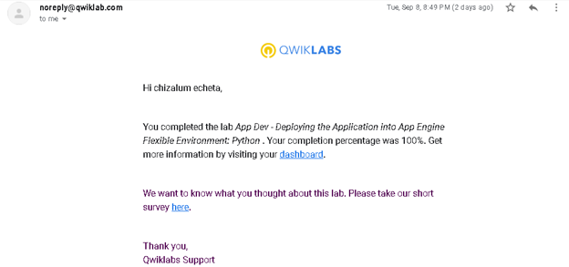

LAB TITLE: APP DEV – DEBUGGING APPLICATION ERRORS: NODE.JS

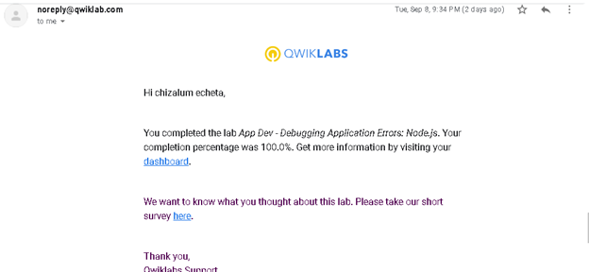

LAB TITLE: APP DEV – HARNESSING STACKDRIVER TRACE AND MONITORING: NODE.JS

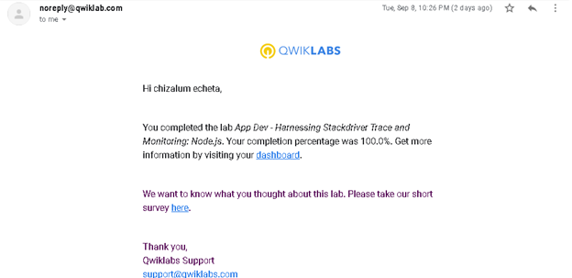

LAB TITLE: APP DEV – ADDING USER AUTHENTICATION TO YOUR APPLICATION: PYTHON

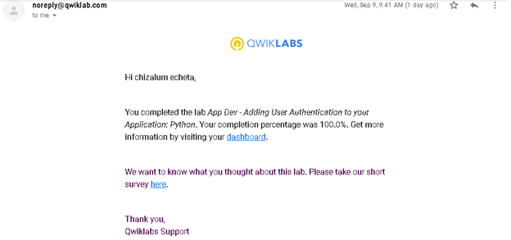

LAB TITLE: PREDICT VISITOR PURCHASES WITH A CLASSIFICATION MODEL WITH BIGQUERY ML

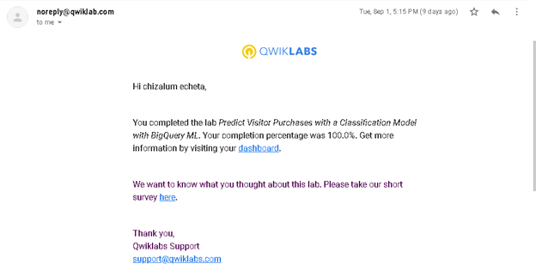

LAB TITLE: RESOURCE MONITORING

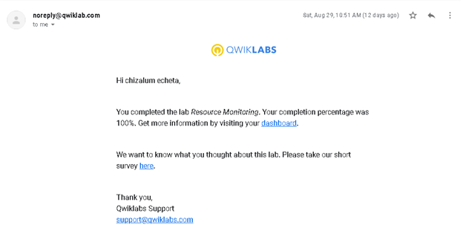

LAB TITLE: INSTALLING CLOUD LOGGING AND MONITORING AGENTS

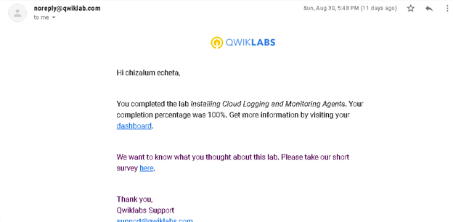

LAB TITLE: CONFIGURING GCLB, CDN, TRAFFIC BLACKLISTING WITH CLOUD ARMOR

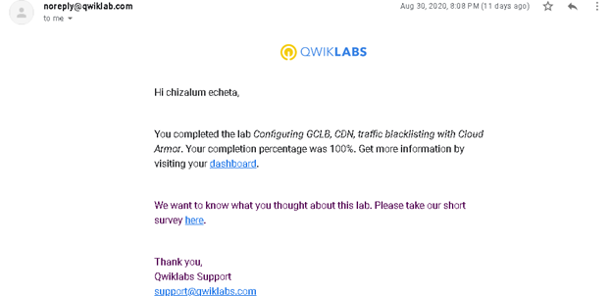

LAB TITLE: AUTOMATING THE DEPLOYMENT OF NETWORKS USING DEPLOYMENT MANAGER

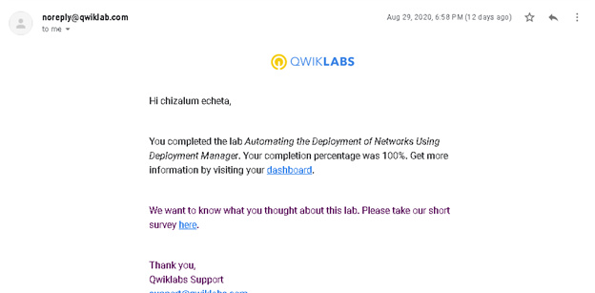

LAB TITLE: CONFIGURING AND USING CLOUD LOGGING AND MONITORING

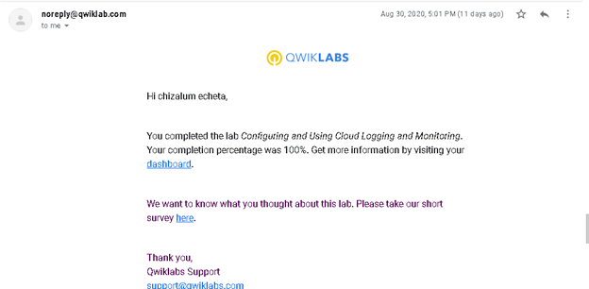

LAB TITLE: GOOGLE CLOUD FUNDAMENTALS: GETTING STARTED WITH CLOUD STORAGE AND CLOUD SQL

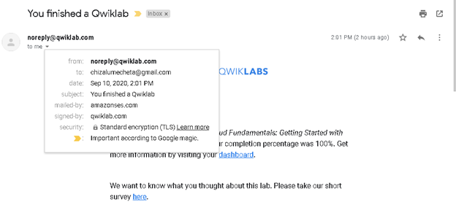

LAB TITLE: IMPLEMENT PRIVATE GOOGLE ACCESS AND CLOUD NAT

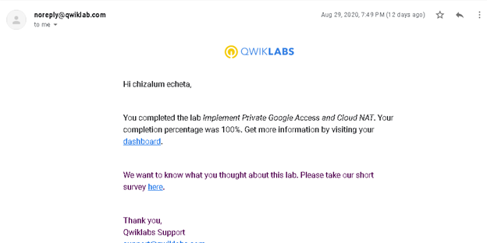

VIRTUAL PRIVATE NETWORKS (VPN)

